H.T No
Regulations:
A22

Sreenidhi Institute of Science and Technology
(An Autonomous Institution)
Code No: 9HC12 Date: 19-Feb-2025 (FN)

B.Tech I-Year II- Semester External Examination, February-2025 (Supplementary)
ADVANCED CALCULUS (Common to All)

Time: 3 Hours Max.Marks:60

Note: a) No additional answer sheets will be provided.
b) All sub-parts of a question must be answered at one place only, otherwise it will not be valued.
c) Missing data can be assumed suitably.
Bloom's Cognitive Levels of Learning (BCLL)

Remember | L1 | Apply | L3 | Evaluate | L5
Understand | L2 | Analyze | L4 | Create | L6

Part - A Max.Marks: 6x2=12

Answer all QUESTIONS, EACH QUESTION CARRIES 2 MARKS.

 |  | BCLL | CO(s) | Marks
1 | Find the first order partial derivatives 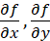 where | L2 | CO1 | [2M]
2 | Evaluate the double integral  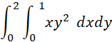 | L2 | CO2 | [2M]
3 | Solve the non linear partial differential equation | L2 | CO3 | [2M]
4 | Find the Fourier coefficient in the Fourier series expansion of | L2 | CO4 | [2M]
5 | Calculate gradient of scalar point function where | L2 | CO5 | [2M]
6 | Write the statement of the vector integral theorem which transforms the surface integral into volume integral. | L1 | CO6 | [2M]

Part – B Max.Marks: 6x8=48
ANSWER ALL QUESTIONS. EACH QUESTION CARRIES 8 MARKS.

 |  |  | BCLL | CO(s) | Marks
7. |  | i). If 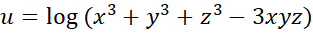 then prove that 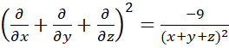  ii). Make use of functional determinant to show that 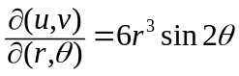 where 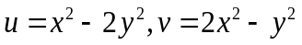 and 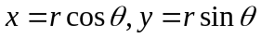 | L3  L2 | CO1  CO1 | [4M]  [4M]
 |  | OR
8 |  | Discuss the nature of stationary points and then find extreme values of | L3 | CO1 | [8M]
9. |  | i). Evaluate the double integral over the area between  ii). Calculate the value of triple integral in cartesian coordinates  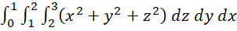 | L4  L3 | CO2  CO2 | [4M]  [4M]
 |  | OR
10 |  | By changing the order of integration, evaluate the double integral  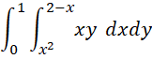 | L5 | CO2 | [8M]
11. |  | i). Form the partial differential equation by eliminating the arbitrary constants from  ii). Solve Lagrange’s linear equation | L3  L3 | CO3  CO3 | [4M]  [4M]
 |  | OR
12 |  | i). Form the partial differential equation by eliminating the arbitrary function from  ii). Solve nonlinear partial differential equation | L3  L3 | CO3  CO3 | [4M]  [4M]
13. |  | Obtain the Fourier series expansion of where 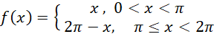 and hence deduce that 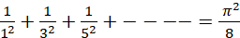 | L4 | CO4 | [8M]
 |  | OR
14 |  | Determine the Fourier series expansion of where 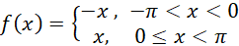 and hence deduce that | L4 | CO4 | [8M]
15. |  | i). Find the directional derivative of at the point in the direction of the line 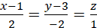  ii). Calculate curl of the vector point function at  where | L3  L2 | CO5  CO5 | [4M]  [4M]
 |  | OR
16 |  | i). Show that the vector  Field  is irrotational and find its scalar potential.  ii). Determine the divergence of the vector point function at the point where | L4  L3 | CO5  CO5 | [4M]  [4M]
17. |  | Apply Green’s theorem to evaluate 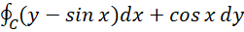 where C is the plane triangle enclosed by the lines 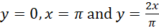 | L4 | CO6 | [8M]
 |  | OR
18 |  | Make use of Stoke’s theorem to evaluate 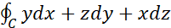 where is the curve of intersection of the spheres and | L4 | CO6 | [8M]

-- 00 -- 00 –

